**Software Engineering Project**

**OPTIONAL ASSIGNMENT 1**: Design of automatic check-in and check-out system in hotel

**Unit 1**: Software Engineering Communication Techniques

**Introduction:**

We want to design a system that allows frequent users of a specific hotel chain to check-in, check-out and order room service automatically without having to talk to anyone in the front desk of the hotel. To do so, we will require two different hardware interfaces: one in the lobby that will allow us to check in or out (we will name it the check machine), and another one in the room (we will name it the room machine) which will allow the customer of the hotel to request room service and pay for it instantly.

Since we did not have access to the customer that was asking us for the design, we took some assumptions:

* The user already has all the credit card details, name and preferences stored in the hotels database, but there are some specific preferences like the room type, the amount of nights or the amount of beds in the room that can be adjusted at the moment of the check-in.
* We assume the user does not have a room assigned and has not paid for the hotel until the check-in is confirmed (then the machine will process the payment depending on the chosen room)
* There are only food services in the room, it’s not possible to ask for services such as pool use or sport installations reservations from the machine
* The hotels use English as international language so the application text is written accordingly
* It is not possible to register in the hotel automatic service from the machine, another method is needed (such as website registration or registration at the front desk)
* Payment of the room service is made automatically in the machine that is located in the room and the receipt of each order is printed there.
* The hotel system keeps track of the room that is assigned with this system to each user therefore knowing the name when the key is returned in the checkout without having to log in
* A room key recovery system is not offered by the machine so if the user loses his key he will have to go to the front desk

**Design mockup:**

**Check Machine:**

Main page:

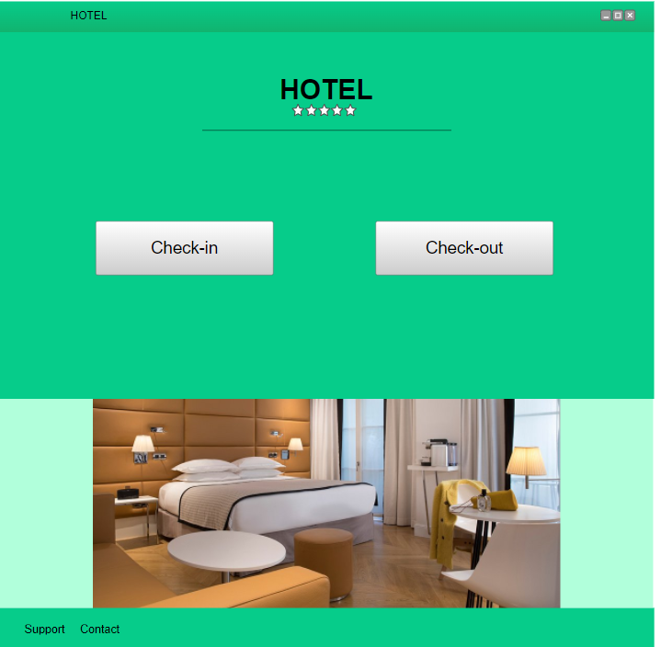

This is the main page of the machine that is located in the lobby. It allows the user to select whether they want to check-in or check-out.

Login when check-in is selected:

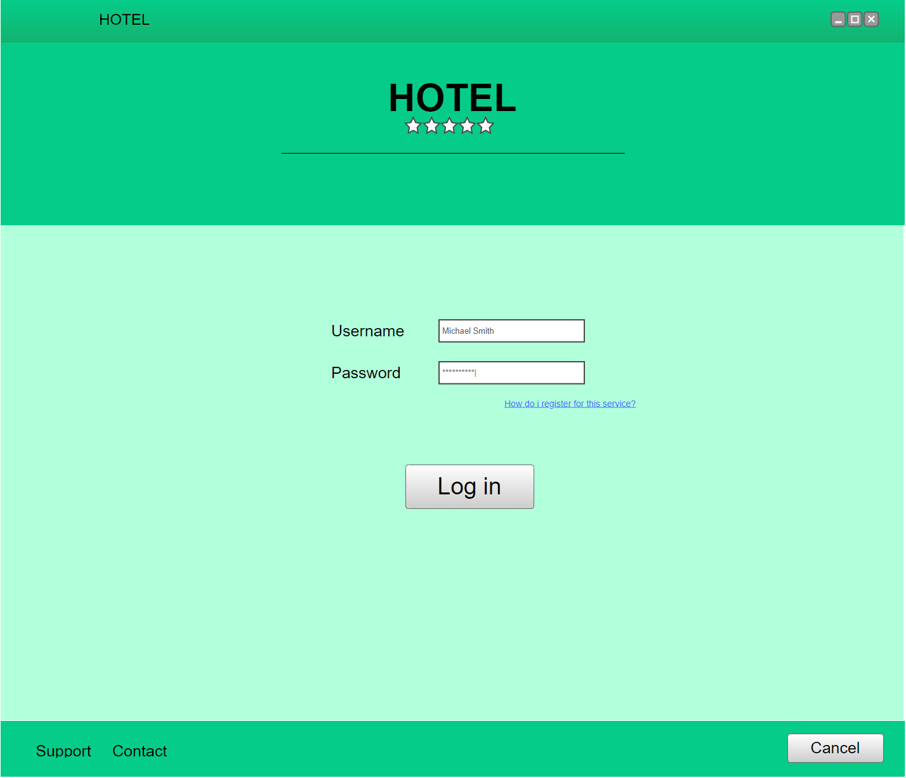

Once check-in is selected the machine asks the user to log in so itr can load his preferences and data stored in the hotel database. It also contains a button to ask for information on how to register for the automatic check-in system.

Check-in a room (and select specifics) when already logged in:

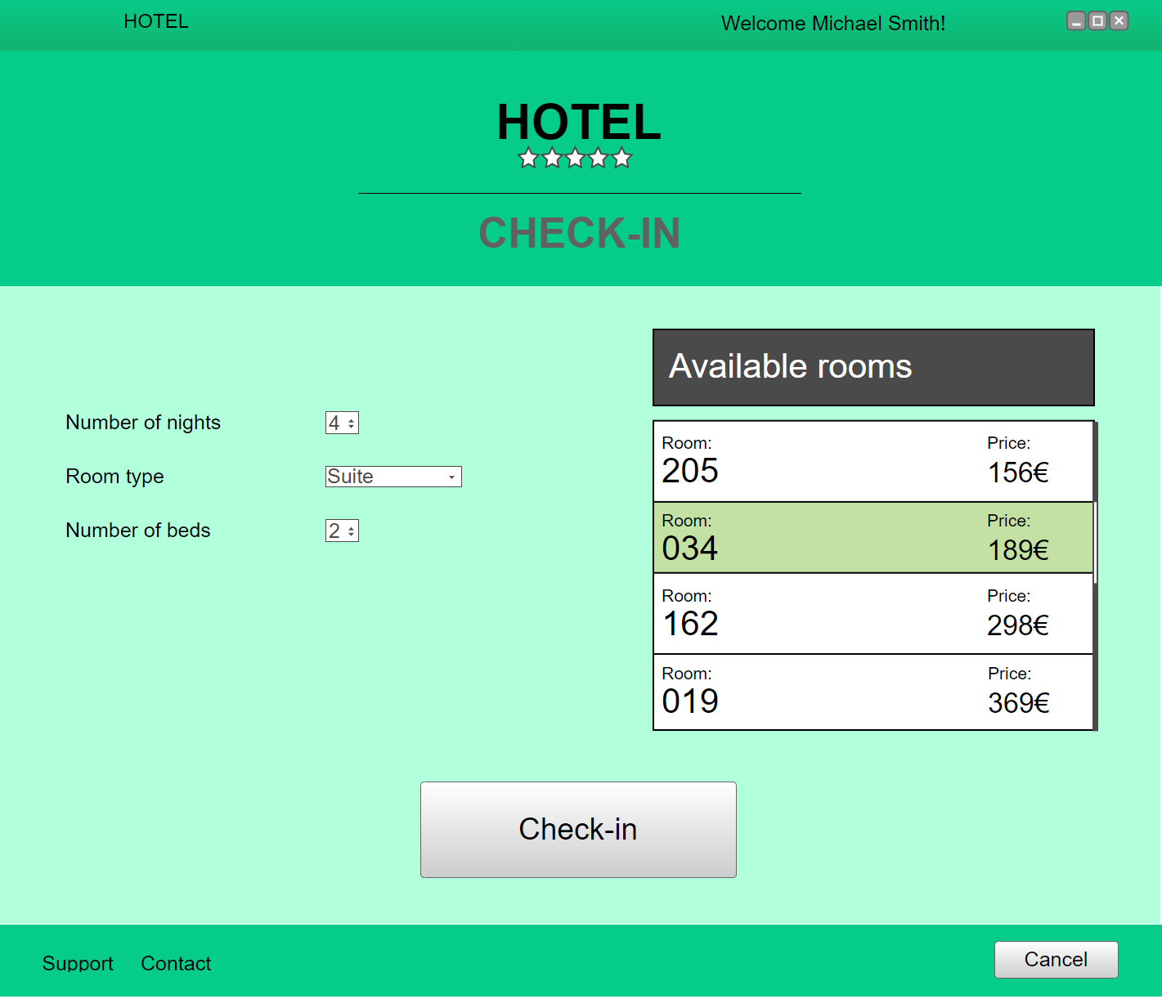

Once the user has logged in after selecting the check-in functionality, the interface allows them to change some preference related to their current stay in the hotel. The user selects the room that adapts to his needs in the room list located in the right of the screen and proceeds to complete the check-in.

Check-in confirmation screen when finalized:

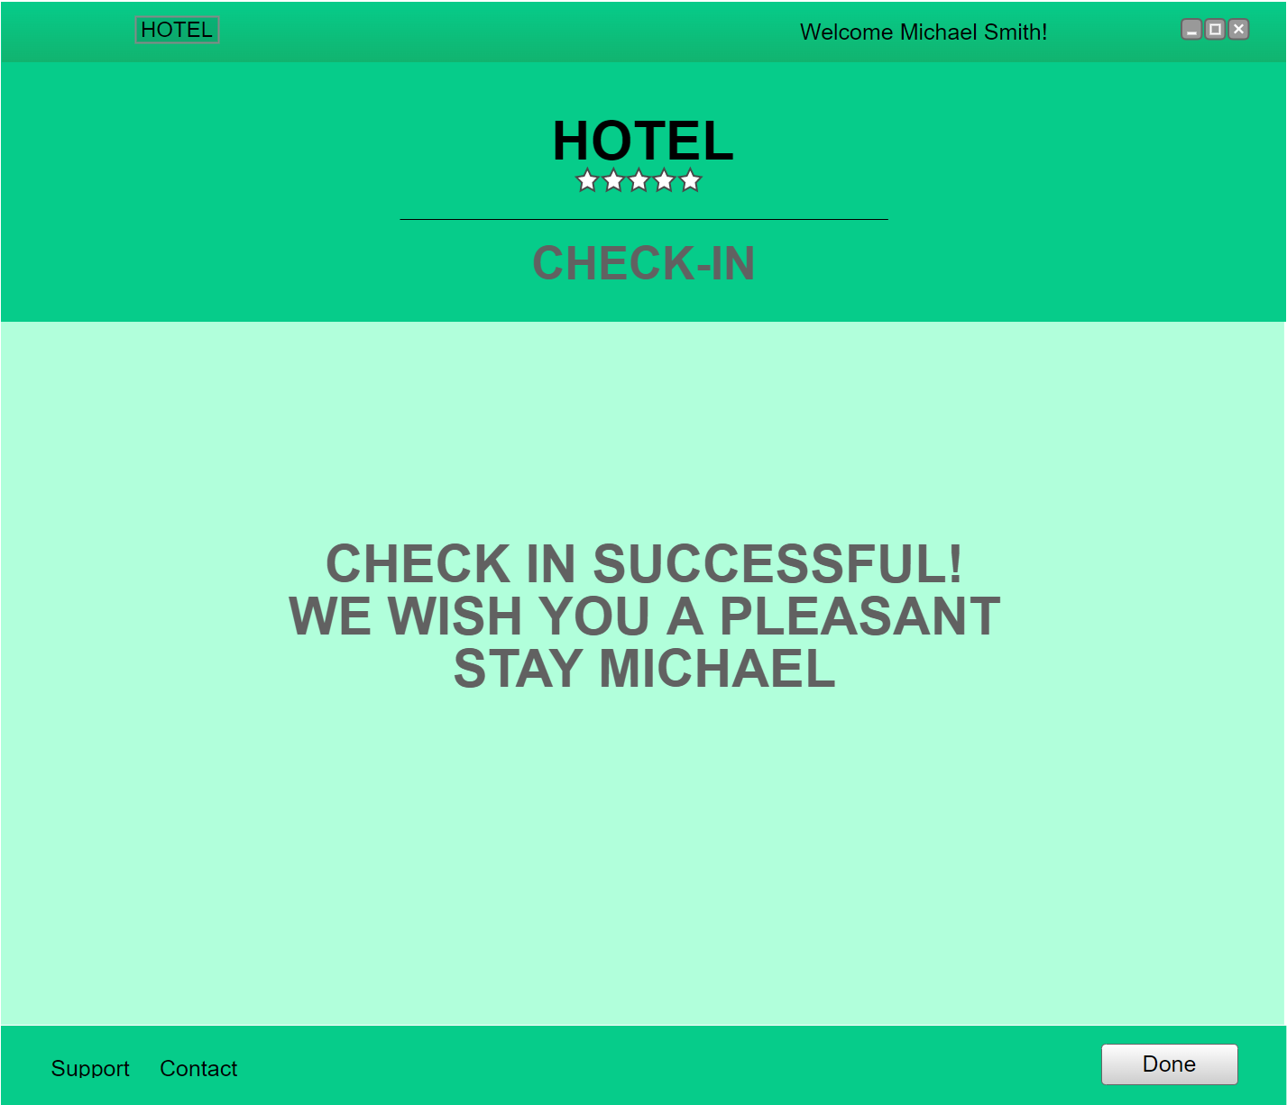

Once the room is selected and the check-in is complete the payment gets processed and this screen is shown to confirm everything has gone as expected. When done the appropriate room key is given by the machine to the user.

Check-out initial screen waiting for the customer to introduce the room key:

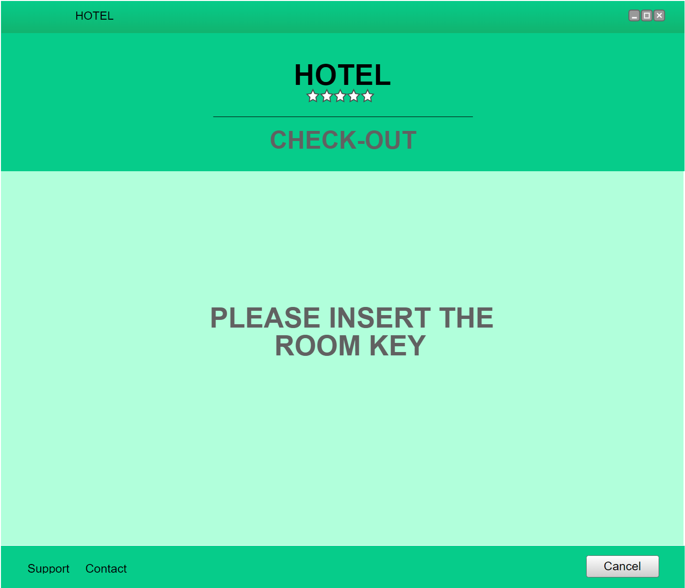

If the check-out option is selected in the main page, this screen is shown while waiting for the user to introduce the room key in the corresponding spot of the machine.

Check-out completed screen:

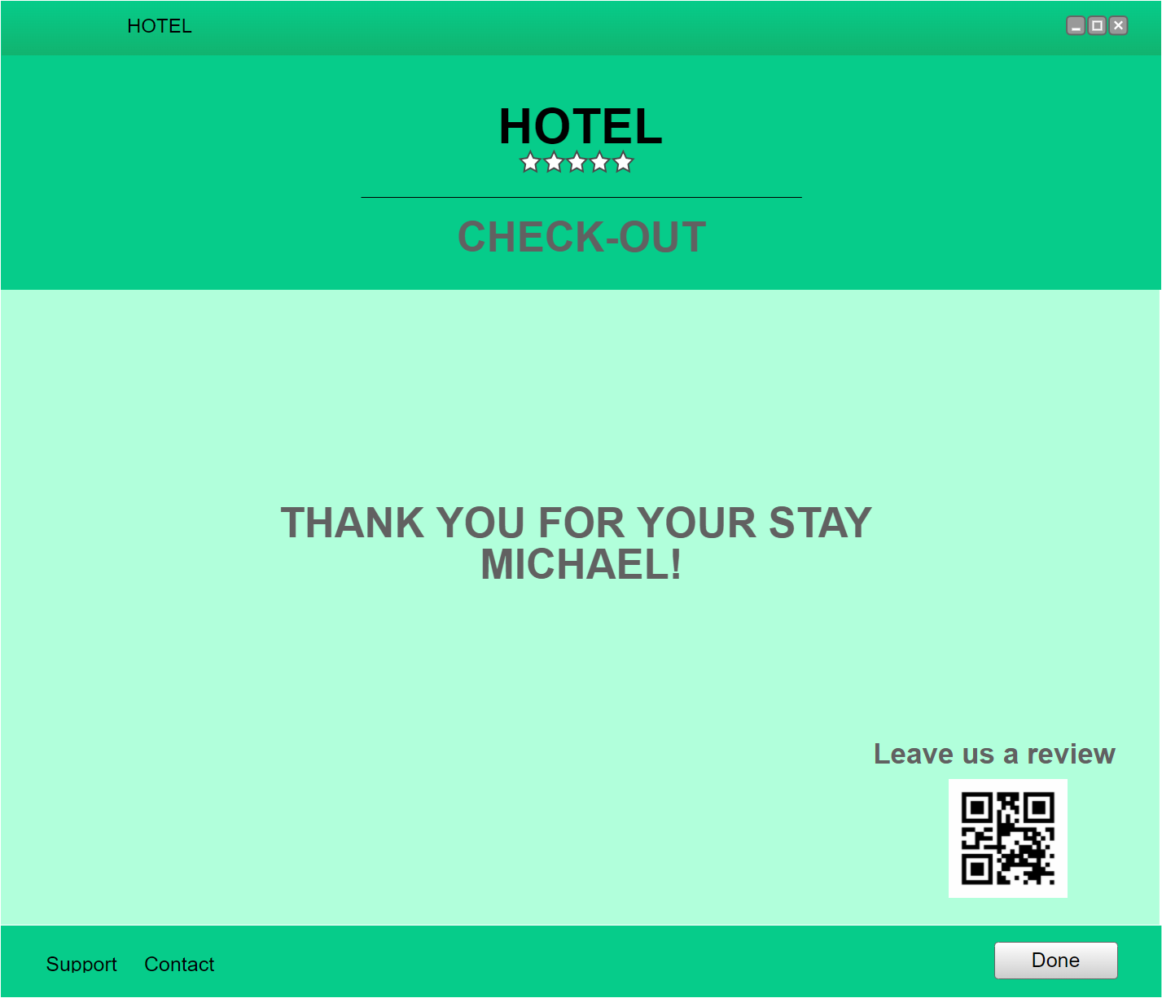

Once the room key is detected by the system this screen is shown where it shows the check-out is over and asks for the user to write a review of his stay by scanning the qr.

Room Machine:

Food Ordering from hotel room

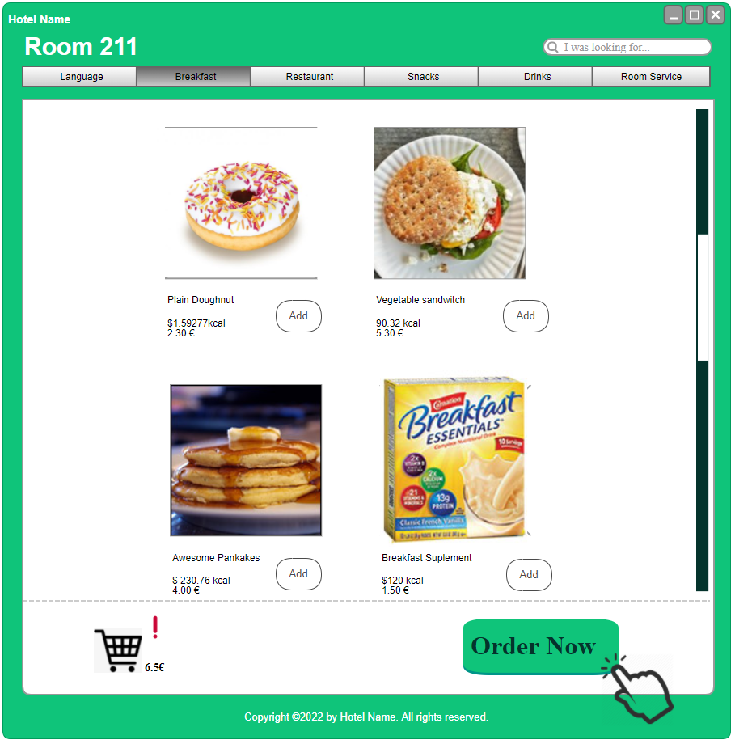

This screen is displayed when the touchscreen of the room machine is pressed, it allows the user to add and remove foods from the cart to order room service

Room service processed:

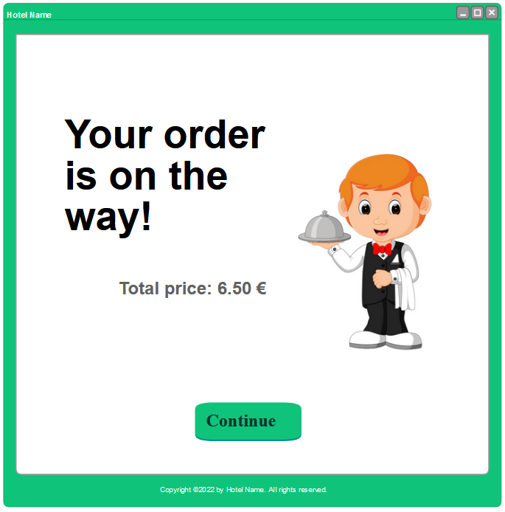

Once the order is placed, the payment is processed and it gets redirected to this confirmation page which prints the receipt.